**DBMS MINI PROJECT:**

**USER MANAGEMENT SYSTEM**

**Submitted by: Sheeraja R (312322205161)**

**Shanmadhi R G (312322205159) Of**

**BACHELOR OF TECHNOLOGY**

**In INFORMATION TECHNOLOGY**



**St. JOSEPH’S COLLEGE OF ENGINEERING**

**(An Autonomous Institution) St. Joseph’s Group of Institutions**

**OMR, Chennai 600 119**

**TABLE OF CONTENTS**

|  |  |  |
| --- | --- | --- |
| **CHAPTER** | **TITLE** | **PAGE NO.** |
| 1. | ABSTRACT | 3 |
| 2. | INTRODUCTION | 4 |
| 3. | PROGRAM | 5 – 7 |
| 4. | WORKFLOW DIAGRAM | 8 |
| 5. | RESULT | 9 |
| 6. | CONCLUSION | 10 |

**ABSTRACT**

Managing user data is crucial for modern applications, ensuring smooth functioning and protecting sensitive information. The User Management System emerges as a pivotal solution, designed to alleviate the complexities associated with user data handling. Developed using Python and SQL technologies, this platform serves as an indispensable tool for streamlining user-related operations and ensuring data integrity.

At its essence, the User Management System serves as a pivotal instrument in the realm of data management, offering a seamless experience for updating, retrieving, and managing user information. By leveraging Python for backend processing and SQL for database management, the system guarantees the security, accessibility, and privacy of user data.

Our project endeavours to simplify and optimize the user management process by providing an array of user-friendly features, including user addition, modification, and deletion. Through a meticulously crafted user interface, users can effortlessly navigate the system, performing a myriad of tasks with unparalleled ease and efficiency.

The integration of Python and SQL technologies underscores our commitment to delivering a robust and scalable solution that meets the evolving demands of modern applications. By prioritizing user experience and data security, the User Management System sets a new standard for user-centric platforms, promising seamless operation and enhanced productivity for businesses and organizations alike.

**INTRODUCTION**

Effective user management lies at the heart of numerous web applications, dictating the seamless handling of user data for enhanced functionality and security. This project introduces a robust User Management System developed using Python and SQL. Python, renowned for its simplicity and versatility, powers the backend operations, orchestrating tasks such as user data processing and database interaction.

Complementing Python, SQL serves as the database management system, ensuring the secure storage and retrieval of user information. Leveraging SQL's relational database capabilities, the system enables efficient data organization and manipulation. Moreover, SQL provides essential features such as data integrity and concurrency control, vital for maintaining the consistency and reliability of user data.

In essence, the User Management System aims to streamline user data management processes, offering features like user addition and modification through a user-friendly interface. By harnessing the capabilities of Python and SQL, this system provides a robust foundation for effective user data management in diverse web applications.

**PROGRAM**

**Index.html:**

<!DOCTYPE html>

<html lang="en">

<head>

<meta charset="UTF-8">

<meta name="viewport" content="width=device-width, initial-scale=1.0">

<title>User Management</title>

</head>

<body>

<h1>User Management</h1>

<form id="userForm">

<label for="name">Name:</label>

<input type="text" id="name" placeholder="name" name="name" required

><br>

<label for="email">Email:</label>

<input type="email" id="email" placeholder="email" name="email" required><br>

<button type="submit">Add User</button>

</form>

<ul id="userList"></ul>

<script>

document.getElementById('userForm').addEventListener('submit', async function(event) {

event.preventDefault();

const name = document.getElementById('name').value; const email = document.getElementById('email').value; const response = await fetch('/users', {

method: 'POST', headers: {

'Content-Type': 'application/json'

},

body: JSON.stringify({ name, email })

});

const data = await response.json(); alert(data.message); document.getElementById('name').value = ''; document.getElementById('email').value = ''; fetchUsers();

});

async function fetchUsers() {

const response = await fetch('/users'); const users = await response.json();

const userList = document.getElementById('userList'); userList.innerHTML = '';

users.forEach(user => {

const li = document.createElement('li'); li.textContent = `${user[1]} - ${user[2]}`; userList.appendChild(li);

});

}

fetchUsers();

</script>

</body>

</html>

**app.py:**

from flask import Flask, request, render_template, jsonify import sqlite3

app = Flask( name ) # Corrected _name_ to name DATABASE = 'database.db'

def init_db():

with sqlite3.connect(DATABASE) as db: cursor = db.cursor() cursor.execute('''

CREATE TABLE IF NOT EXISTS users (

id INTEGER PRIMARY KEY AUTOINCREMENT, name TEXT NOT NULL,

email TEXT NOT NULL

) ''')

db.commit()

@app.route('/') def index():

return render_template('index.html')

@app.route('/users', methods=['GET', 'POST'])

def users():

if request.method == 'GET':

print("GET request received for /users") db = get_db()

cursor = db.execute('SELECT * FROM users') users = cursor.fetchall()

db.close()

return jsonify(users)

elif request.method == 'POST': data = request.json

name = data.get('name') email = data.get('email')

print("POST request received for /users") print(f"Name: {name}, Email: {email}") db = get_db()

db.execute('INSERT INTO users (name, email) VALUES (?, ?)', (name,

email))

db.commit() db.close()

return jsonify({'message': 'User added successfully'})

def get_db():

db = sqlite3.connect(DATABASE) return db

if name == ' main ': # Corrected _name_ to name init_db() # Initialize the database app.run(debug=True)

**WORKFLOW DIAGRAM**

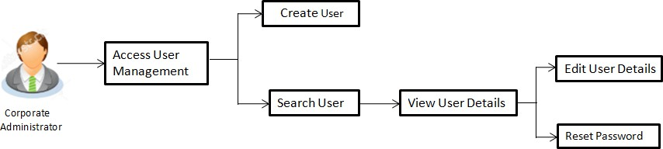

**OUTPUT**

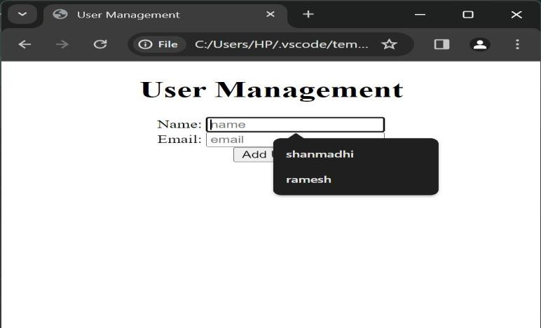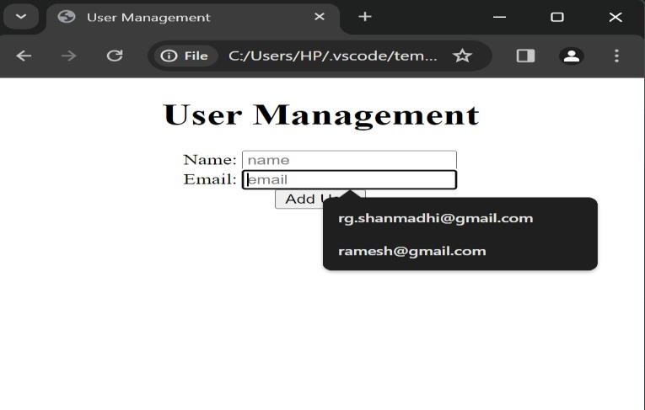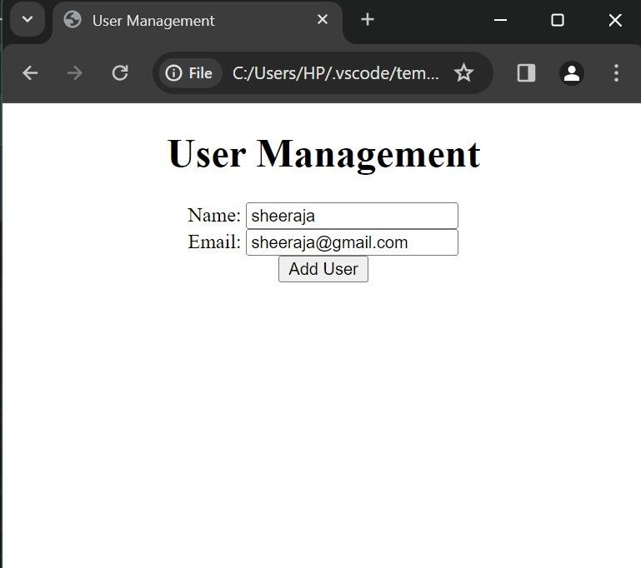

**CONCLUSION**

In summary, our user management system built with Flask and SQLite offers an easy way to handle user information on the web. Users can add, view, update, and delete their data through a user-friendly interface.

With Flask handling the backend and SQLite managing the database, the system ensures smooth operations. Users input their details through simple forms, which are then stored securely in the database.

The system's design is responsive and intuitive, providing a hassle-free experience for users. Plus, with AJAX requests, data updates happen seamlessly without refreshing the page.

Overall, our user management system showcases the simplicity and effectiveness of Flask and SQLite for creating efficient web applications. It's a versatile tool that can be adapted to suit various organizational needs, making user data management straightforward and accessible.